
Navigating the SOA
Open Standards Landscape Around Architecture
A paper edited by:
Heather Kreger, IBM
Jeff Estefan, NASA/Jet Propulsion Laboratory
July 2009

OMG Note: This paper presents a discussion of technology issues considered in a Special Interest Group of the Object Management Group. The contents of this Paper are presented to create discussion in the computer industry on this topic; the contents of this paper are not to be considered an adopted standard of any kind. This does not represent the official position of the Object Management Group.

Copyright © 2009 The Open Group. All rights reserved.

This document and translations of it may be copied and furnished to others, and derivative works that comment on or otherwise explain it or assist in its implementation may be prepared, copied, published, and distributed, in whole or in part, without restriction of any kind, provided that the above copyright notice and this section are included on all such copies and derivative works. However, this document itself may not be modified in any way, including by removing the copyright notice or references to The Open Group, without the permission of the copyright owners. This document and the information contained herein is provided on an "AS IS" basis and THE OPEN GROUP DISCLAIMS ALL WARRANTIES, EXPRESS OR IMPLIED, INCLUDING BUT NOT LIMITED TO ANY WARRANTY THAT THE USE OF THE INFORMATION HEREIN WILL NOT INFRINGE ANY OWNERSHIP RIGHTS OR ANY IMPLIED WARRANTIES OF MERCHANTABILITY OR FITNESS FOR A PARTICULAR PURPOSE.

Copyright © 2009 OASIS. All rights reserved.

All capitalized terms in the following text have the meanings assigned to them in the OASIS Intellectual Property Rights Policy (the "OASIS IPR Policy"). The full Policy may be found at the OASIS website. This document and translations of it may be copied and furnished to others, and derivative works that comment on or otherwise explain it or assist in its implementation may be prepared, copied, published, and distributed, in whole or in part, without restriction of any kind, provided that the above copyright notice and this section are included on all such copies and derivative works. However, this document itself may not be modified in any way, including by removing the copyright notice or references to OASIS, except as needed for the purpose of developing any document or deliverable produced by an OASIS Technical Committee (in which case the rules applicable to copyrights, as set forth in the OASIS IPR Policy, must be followed) or as required to translate it into languages other than English. The limited permissions granted above are perpetual and will not be revoked by OASIS or its successors or assigns. This document and the information contained herein is provided on an "AS IS" basis and OASIS DISCLAIMS ALL WARRANTIES, EXPRESS OR IMPLIED, INCLUDING BUT NOT LIMITED TO ANY WARRANTY THAT THE USE OF THE INFORMATION HEREIN WILL NOT INFRINGE ANY OWNERSHIP RIGHTS OR ANY IMPLIED WARRANTIES OF MERCHANTABILITY OR FITNESS FOR A PARTICULAR PURPOSE.

OASIS™ is a trademark of OASIS.

BPMN™, Business Process Modeling Language™, OMG™, Object Management Group™, SoaML™, SysML™, and Unified Modeling Language™ are trademarks and CORBA®, MDA®, Model Driven Architecture®, and UML® are registered trademarks of the Object Management Group, Inc. in the United States and other countries.

Boundaryless Information Flow™ and TOGAF™ are trademarks and Making Standards Work®, The Open Group®, UNIX®, and the “X” device are registered trademarks of The Open Group in the United States and other countries.

All other brand, company, and product names are used for identification purposes only and may be trademarks that are the sole property of their respective owners.

Navigating the SOA Open Standards Landscape Around Architecture

Document No.: W096

Published by The Open Group, July 2009

Any comments relating to the material contained in this document may be submitted to The Open Group, 44 Montgomery St. #960, San Francisco, CA 94104, USA or by email to ogspecs@opengroup.org.

Acknowledgements
Table of Contents
Acknowledgements 4
Executive Summary 5
Introduction 6
Nomenclature 6
Audiences for SOA Standards 7
Referenced Documents 8
Description of Targeted SOA Open Standards Technical Products 11
Technical Products Related to Core SOA Concepts 11
Technical Products Related to SOA Maturity 11
Technical Products Related to Architecture 11
Technical Products Related to Modeling Languages 13
Influence of Technical Products 14
How the Technical Products Fit Together 15
SOA Core Concepts 19
Open Standards Work on SOA Governance 20
SOA Governance Concepts 20
Guidance and Usage of Technical Products 22
Core Concepts 22
Architectures 22
Maturity 23
Modeling Languages 23
Summary 24
References 25
Papers and Briefings 25
Formal Specifications, Standards, and RFPs 25
Technical Committees, Work/Working Groups, Interest Groups 26
About the Authors 28
About the OASIS SOA-RM TC 28
About OMG 28
About The Open Group 28

We would like to thanks the following individuals for their participation and contribution to the development of this document:
Jim Amsden, IBM (OMG)
Ali Arsanjani, IBM (The Open Group)
Anthony Carrato, IBM (The Open Group)
Carleen Christner, HP (The Open Group)
Eric Dabbaghchi, MITRE (The Open Group)
Jorge Diaz, IBM (The Open Group)
Bob Ellinger, Northrop Grumman (OASIS SOA-RM TC)
Jeff Estefan, NASA/Jet Propulsion Laboratory (OASIS SOA-RM TC)
Ahmed Fattah, IBM (The Open Group)
Leonard Fehskens (The Open Group)
Mats Gejnevall, Capgemini (The Open Group)
Chris Greenslade, CLARS Ltd. (The Open Group)
Chris Harding (The Open Group)
Ed Harrington, Model Driven Solutions (OMG, The Open Group)
Allen Jones, Boeing (The Open Group)
Heather Kreger, IBM (OASIS SOA-RM TC, The Open Group)
Nikhil Kumar, Applied Technology Solutions (The Open Group)
Robert Laird, IBM (The Open Group)
Ken Laskey, MITRE (OASIS SOA-RM TC)
Milena Litoiu, CGI (The Open Group)
Sinan Madenli, CGI (The Open Group)
Francis McCabe (OASIS SOA-RM TC)
Bruce Miner, Direct Energy (The Open Group)
Duane Nickull, Adobe (OASIS SOA-RM TC)
James Odell, CSC (OASIS, OMG)
Harsh Sharma, Metlife (OMG)
Andras Szakal, IBM (The Open Group)
Executive Summary
An abundance of specifications and standards have emerged from the open standards organizations of OASIS, OMG, and The Open Group on the subject of Service Oriented Architecture (SOA). This joint document – contributed to by members of the OASIS SOA Reference Model Technical Committee (OASIS SOA-RM TC), OMG, and The Open Group – was written to help the SOA community at large to navigate the myriad of overlapping technical products produced by these organizations with specific emphasis on the “A” in SOA; i.e., Architecture.
This document explains and positions architectural standards for SOA reference models and ontologies, reference architectures, maturity models, SOA modeling languages, and open standards work related to the topic of SOA governance. It also outlines the agreement on core SOA and SOA governance concepts. This document is intended to serve as a guide to the reader to help differentiate and select specifications appropriate to their needs.
The specifications introduced and positioned in this document include the OASIS Reference Model for SOA, the OASIS Reference Architecture for SOA Foundation, the OMG SoaML Specification, The Open Group SOA Ontology, The Open Group SOA Reference Architecture, The Open Group SOA Governance Framework, and The Open Group Service Integration Maturity Model (OSIMM).
This document outlines where the works are similar and helps users of the technical products produced by the open standards organizations to understand the strengths of each body of work and select the technical products most appropriate for their needs, consistent with where they are today, and where they plan to head on their SOA journeys.
A secondary goal was to facilitate collaboration between the standards bodies to encourage consistency across the standards addressing the various aspects of SOA. It is anticipated that future work on SOA standards may consider the relative positioning described here to reduce overlaps and gaps between related standards.
Introduction
This document is written to provide guidance to readers of various Service Oriented Architecture (SOA) standards and specifications published by the Organization for the Advancement of Structured Information Standards (OASIS), the Object Management Group (OMG), and The Open Group, on how these standards and specifications relate to each other. It is also intended to help clarify which documents are relevant to their particular interests or needs as educational material to help better understand the SOA open standards landscape.
This document does not detail all of the relevant SOA open standards work, but rather focuses on the distinguishing features of SOA reference models, reference architectures, maturity models, ontologies, modeling languages, and governance specifications. As stated earlier, it is intended to serve as a guide to the reader to help differentiate the current and emerging specifications in that space, which is by no means a trivial undertaking. (See Figure 1 for a more complete picture of standards work in this space.) We recognize that many other standards also play an important role in designing, implementing, and deploying a practical Service-Oriented Architecture; but the breadth of all of these activities is beyond the scope of this document.
This document covers all audiences (see Audiences for SOA Standards), although a particular document referenced may be aimed at a more narrow audience, such as the business, solution, and enterprise architects who are the primary target practitioners seeking to leverage SOA open standards reference models, reference architectures, ontologies, and SOA modeling languages as part of their work.

Nomenclature
This section introduces some of the classifications of architecture standards which are used to facilitate the positioning in this document. These are not intended to be formal definitions that either replace or unify the definitions in the various specifications. Rather, the terms are recapped here, summarizing the commonality and some of the differences between the terms as defined in the current specifications to further understanding.
- Reference Models – The OASIS Reference Model for SOA [5] defines a reference model as an abstract framework for understanding significant relationships among the entities of some environment. It enables the development of specific reference or concrete architectures using consistent standards or specifications supporting that environment. A reference model consists of a minimal set of unifying concepts, axioms, and relationships within a particular problem domain, and is independent of specific standards, technologies, implementations, or other concrete details.
- Reference Architectures – Reference architectures, like other architectures, can be defined at different levels of abstraction ranging from foundation architectures to common systems architectures, and industry and organization-specific architectures. An example of this relationship is shown in Figure 1.
The OASIS Reference Architecture for SOA Foundation [6] defines reference architecture as follows: “a reference architecture models the abstract architectural elements in the domain independent of the technologies, protocols, and products that are used to implement the domain).” This definition is at the foundation end of the TOGAF architecture [5] continuum, depicted in Figure 3.
The Open Group SOA Reference Architecture [17] defines reference architecture as: “providing a template, based on the generalization of a set of past successful solutions. These solutions have been generalized and structured for the depiction of both a logical and physical architecture based on the harvesting of a set of patterns that describe observations in a number of successful implementations. Further, it shows how to compose these architectures together into a solution.” This is closer to the TOGAF [11] Common Systems Architectures. These reference architectures will be evolved and instantiated as an industry architecture or organization-specific architecture for a particular domain of interest or for specific projects. They are useful to guide the work of the solution team, including constraining choices in developing the solution.
- Ontologies – Gruber [3] defines an ontology as: “an explicit formal specification of the terms in the domain and relations among them.” Ontologies are useful to ensure that information items are defined in a standard and coherent manner, across teams. Ontologies formally describe the elements of and provide a language for both reference models and reference architectures. The formal representation allows for an evaluation of consistency and provides a means to apply formal reasoning in evaluating instances of the domain. The representation may also be used to support model interchange and extensibility [57].
- Maturity Models – A maturity model represents a means of and scale for both evaluating and assessing the current state of maturity of a particular entity with respect to a particular capability. It also provides a means for developing a value proposition and transformation roadmap to achieve a target state of maturity from a given current state of maturity. It quantifies the relative growth of certain salient aspects within various dimensions typically within, but not limited to, organizational boundaries. A maturity level is defined by a set of characteristics or capabilities which can be measured and assessed for a domain [16].
- Modeling Languages – Modeling languages include a metamodel and notation that may be used to provide a standard means of representing artifacts in tools and in communicating information between tools and automated environments. A modeling language such as the Unified Modeling Language (UML) from the OMG [10] may be extended by profiles that tailor a model or modeling language for a specific domain or purpose.
Examples of modeling languages include the OMG Systems Modeling Language (OMG SysML) and, more closely related to the subject of this document, the OMG SOA Modeling Language (OMG SoaML) [9]. Modeling languages, metamodels, profiles, and tools can be used with most architecture specifications.
- Concrete/Solution Architectures – A concrete architecture is an instantiation of a reference architecture achieved by substitution of the general, logical, abstract elements of the template with concrete or physical realizations by vendor products and instances of technical products, standards, protocols, and design/architectural decisions. Industries can instantiate concrete architectures for their usage context. Concrete/solution architectures are used directly to drive project implementations.

Audiences for SOA Standards
There are a number of SOA-related specifications and standards that provide different explanations of the same concepts from different points of view.
The intent of this document is to provide context so that, regardless of which organization or specification forms a reader’s starting point, the same basic understanding of the relationship among SOA standards and fundamental concepts is conveyed.
These SOA specifications and standards are meant to provide value for readers with the following roles:
- Business Architects and Analysts will find them useful for determining how to best exploit SOA to create timely, re-usable, agile business solutions.
- Architects will find them useful as a starting point for customizing their own reference and concrete architectures for SOA.
- Developers/Practitioners will find them essential as a basis of their development of SOA implementations.
- Customers/SOA Adopters will find them useful for education on SOA and a set of terms and understandings that they can expect vendors to use in a consistent manner.
- Vendors – including suppliers of hardware and software, solution providers, and service providers – will find them useful to provide a consistent, standardized context in which to position and differentiate their specific products and services. They also provide a shared understanding between different types of vendors and customers.
- Analysts will find them useful to explain the relationships between specifications, between standards organizations, and between vendor products and services offerings.
- Standards Organizations will find them useful for understanding SOA and for building upon in a consistent manner.

Referenced Documents
The numerous technical products in the SOA standards space reflect knowledge captured as different perspectives of the same subject for different purposes and audiences. As such, there are cases where these specifications have captured overlapping knowledge.
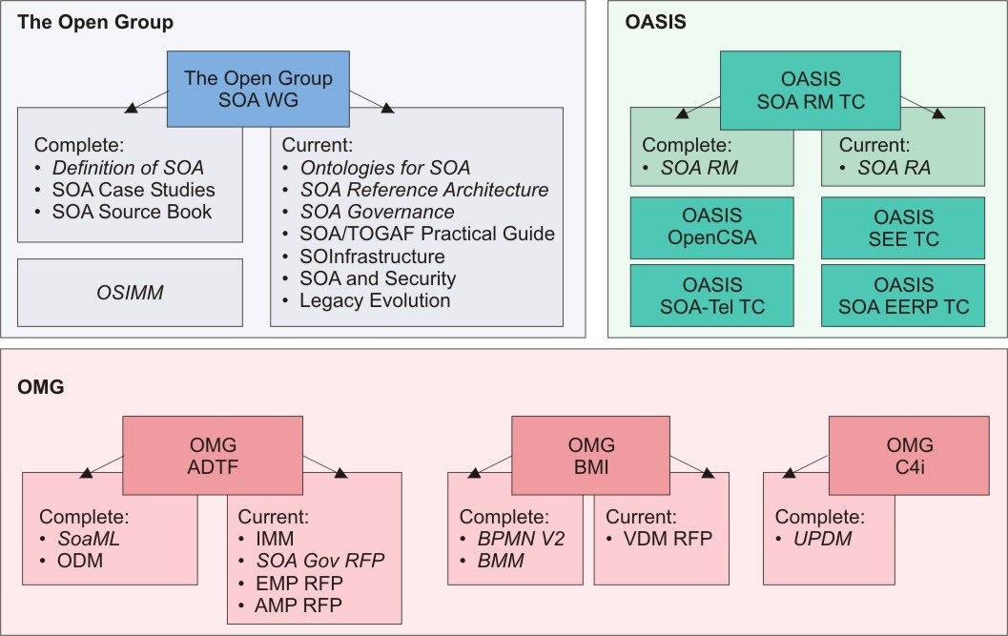
Figure 1: Specifications of SOA Open Standards Working/Work Groups, Technical Committees, and Special Interest Groups
Figure 1 depicts some of the numerous SOA working groups, work groups, technical committees, and submission teams from some of the open standards organizations that have been, or are in the process of, producing technical products related to SOA, including formal SOA specifications and standards. Many other complimentary standards are useful for business and enterprise architecture, information modeling, business processes, SOA implementation, and SOA infrastructure that have been defined by the W3C [49], OMG [50-58], OASIS [22-33], and other organizations not listed here. We recognize that many of these other standards, including BPMN, also include support for services that play an important role in contributing to and using SOA. In a similar way, a number of related W3C technologies will be vital to many implementations, but are not discussed here. The breadth of all of these activities is beyond the scope of this document. Here, we are primarily focused on architectural standards for SOA reference models and ontologies, reference architectures, maturity models, SOA modeling languages, and open standards work related to the topic of SOA governance.
The specific SOA open standards technical products referenced and positioned in this document include the following. Links to these technical work products, work groups, and organizations can be found in References.
- The OASIS Reference Model for SOA [5]
- The OASIS Reference Architecture for SOA Foundation [6]
- The OMG SOA Modeling Language (OMG SoaML) [9]
- The Open Group SOA Ontology [14]
- The Open Group SOA Governance Framework [15]
- The Open Group Service Integration Maturity Model (OSIMM) [16]
- The Open Group SOA Reference Architecture [17]
Each of these technical products is further described in the following section. Again, it should be noted that this is not a complete picture of the SOA open standards landscape, but rather a limited set that focuses on attempts to harmonize core SOA concepts and architecture being proposed by these open standards organizations.
This document positions and compares these specifications so that readers can understand how these technical products relate to each other, where they share the same scope, and where they provide different ways to express the same fundamental concepts. This document also notes points of inconsistency in the approach to understanding SOA.
Description of Targeted SOA Open Standards Technical Products
This section provides a short summary of each of the technical products. The summaries have been categorized according to those related to core SOA concepts, maturity, architecture, and modeling languages. It wraps up with a summary of how the specifications have influenced each other’s development.

Technical Products Related to Core SOA Concepts
The OASIS Reference Model for SOA [5] is intended to capture the “essence” of SOA, as well as provide a vocabulary and common understanding of SOA. The goals of the reference model include a common conceptual framework that can be used consistently across and between different SOA implementations, common semantics that can be used unambiguously in modeling specific SOA solutions, unifying concepts to explain and underpin a generic design template supporting a specific SOA, and definitions that should apply to all SOA. The reference model provides a normative reference that remains relevant for SOA as an abstract, powerful model, regardless of the inevitable technology changes that have influenced or will influence SOA deployment.
The Open Group SOA Ontology [14] is similar to the above OASIS Reference Model for SOA in that it captures a set of related concepts within the SOA space and explains what they are and how they relate to each other. The objectives are to facilitate understanding of these terms and concepts within the context of SOA, and potentially to facilitate model-driven implementation. The ontology is represented in OWL (Web Ontology Language) [19] to enable automation and allow tools to process it; for example, reasoning applications could use the SOA ontology to assist in service consumer and provider matching, service value chain analysis, and impact analysis. The formal representation enables integration with other concerns such as business motivation modeling, business process modeling, information modeling, operations modeling, portfolio management, etc.
Note that The Open Group SOA Ontology and the OASIS Reference Model for SOA are very closely aligned, although some terms may represent different architectural views. The difference in expression or naming of concepts does not affect the basic understanding of SOA or the derivative architectures.

Technical Products Related to SOA Maturity
The Open Group Service Integration Maturity Model (OSIMM) [16] provides corporations and IT practitioners with a means to assess an organization’s maturity within a complete SOA migration path. It provides a means to create a roadmap for incremental adoption which maximizes business benefits at each stage along the way. The model consists of seven levels of maturity and seven dimensions of consideration within an organization or scope defined by a project, and acts as a quantitative model to aid in assessment of a current state and designation of a desired future state.

Technical Products Related to Architecture
Both of the reference architectures for SOA that are described below are technology-neutral, intended to guide other architectures, and raise questions and decision points for architects.
The OASIS Reference Architecture for SOA Foundation [6] is a view-based abstract reference architecture foundation that models SOA from an ecosystem/paradigm perspective. It specifies three viewpoints; specifically, the Service Ecosystem viewpoint, the Realizing SOAs viewpoint, and the Owning SOAs viewpoint. Each of the associated views that are obtained from these three viewpoints is briefly described below. Since it is an abstract and foundational reference architecture, it does not contain the level of specificity required to directly implement SOA-based systems. It does provide UML models and architectural implications for each of the views useful in guiding other architecture work, including other reference architectures, as architects become more enterprise and/or solution-oriented.
The Service Ecosystem view contains models that are intended to capture how SOA integrates with and supports the service model from the perspective of the people who perform their tasks and achieve their goals as mediated by SOAs. Since the Service Ecosystem viewpoint (on which this view is based) emphasizes the use of SOA to allow people to access and provide services that cross ownership boundaries, it is explicit about those boundaries and what it means to cross an ownership boundary.
The Realizing SOAs view contains models for description of, visibility of, interaction with, and policies for services.
The Owning SOAs view contains models for securing, managing, governing, and testing SOA-based systems.
The Open Group SOA Reference Architecture [17] is intended to support the understanding, design, and implementation of common system, industry, enterprise, and solution architectures leveraging the principles of an SOA.
This SOA reference architecture provides the basis, or blueprint, for an enterprise architecture so that the enterprise architect can use that template or blueprint as a standard that will be instantiated during each individual project or solution that is being developed. This will be performed within the organization where the SOA reference architecture will be instantiated.
This SOA reference architecture is designed to support different kinds of scenarios including those involving consumer organizations, vendors, other standard bodies, and other Open Group projects. Specifically The Open Group SOA Reference Architecture:
- Assists and guides consumer organizations designing and implementing an SOA by providing a concrete basis for evaluating and making architectural and design decisions
- Supports and provides a vehicle for vendors using this SOA reference architecture to define their solutions and map their specific products to the architectural models
- Provides a reference for other standards bodies and Open Group work streams to use in the context of understanding SOA and providing a model for them to map against
The Open Group SOA Reference Architecture can be used in the following ways:
- To understand the different elements of an SOA, including the key architectural elements in it and the key relationships between these elements
- As a vehicle to provide traceability to and mapping between the common systems architecture (which the SOA reference architecture represents) and specific industry and organizational architectures
- To provide a model and framework for determining and evaluating the set of relevant architectural concerns for designing an SOA
Further, it can be used as a guide to refining the SOA reference architecture (common systems architecture) into a domain (industry) or enterprise (organization) reference architecture and to instantiating it to produce a concrete architecture.
The Open Group SOA Reference Architecture can represent both abstract enterprise scale designs as well as concrete SOA implementations.
This SOA reference architecture uses a partially layered approach since one layer does not solely depend upon the adjacent layers. Layers are defined around sets of key architectural concerns and capabilities, the interaction protocols between layers, and the details within a layer using a set of architectural building blocks. There are five functional horizontal layers and four non-functional vertical layers that support various cross-cutting concerns of the SOA architectural style.
This SOA reference architecture consists of a set of conceptual elements, such as layers, architectural building blocks, and their mutual interactions. These elements need to be instantiated by making architectural and realization decisions on what vendor products, parts of products, standards, and protocols will be used to instantiate a given architectural building block. This allows and facilitates the creation of solutions based on the reference architecture, at different levels; namely a logical down to the physical instantiation of a concrete architecture.

Technical Products Related to Modeling Languages
Business and IT architects also employ methodologies for modeling and building architectures. As such, architectural methodologies have emerged with the advent of Model Driven Architecture (MDA) [20], a technical product of the OMG. For working with SOA and using the Unified Modeling Language (UML) [10] as the primary syntax, the OMG SoaML specification [9] provides guidance and a metamodel to help architects and other strategic thinkers link the design of real world SOA-based systems into their architecture work.
SoaML is an OMG standard that defines extensions to UML for services modeling and provides functional, component, and service-oriented modeling capabilities. Each of these modeling approaches provides different, enhanced capabilities for dealing with cohesion and coupling in complex systems. SoaML extends UML in order to provide additional capabilities for managing cohesion and coupling afforded by an SOA style. SoaML is applicable across a broad range of domains and levels of abstraction from business services to detailed IT services. Using a common language for these different purposes simplifies systems modeling and integration of separate concerns in order to enable business agility which can be represented with business architecture models such as BMM and BPMN. SoaML can be viewed as supporting instantiation of the OASIS Reference Model for SOA [5] that provides a concrete platform for services modeling integrated with UML and supporting OMG MDA.
The purpose of the SoaML standard is to address service modeling, not methodologies for determining what the services model should be, or how it would be used in any particular context. The standard is intended to be sufficiently detailed to define platform-independent SOA models (PIM) that can be transformed into platform-specific models (PSM) for particular technical architectures as described by the OMG MDA. The scope of SoaML does not cover SOA governance or compliance, quality of services (policy, trust, performance, etc.), message delivery reliability, wire-level protocols, service brokering, publishing discovery, etc. Rather, it is expected that SoaML will be integrated with other standards that already address these concerns, or be extended over time to support them directly. The intent of SoaML was to provide a foundation for integration, interoperability, and extension.
The fundamental element of SoaML is the participant, representing a service consumer and/or provider. Participants express their goals, needs, and expectations through requests for services as defined by service interfaces or service contracts. Other participants express their value propositions, capabilities, and commitments through services. Participants are then assembled into service value chains where participant requests are connected to the compatible services of other participants through service channels through which they interact. SoaML uses facilities of UML to define the services interfaces and method behaviors for carrying out and using services. SoaML also defines autonomous agents that can choreograph participants in a service value chain while adapting to the changing needs of the community of collaborating participants. SoaML provides a means of defining milestones that indicate the achievement of progress toward achieving the desired real-world effect of the services value chain, and for evaluating different approaches to achieving progress by different participants.

Influence of Technical Products
Figure 2 shows the influences of the various SOA open standard technical products (i.e., specifications, standards, etc.) on each other. Since the OASIS Reference Architecture for SOA Foundation [6], The Open Group SOA Ontology [14], and OMG SOA Modeling Language (OMG SoaML) [9] were all based on the OASIS Reference Model for SOA [5] with refinements and extensions, there is some natural affinity between these works. It should be noted that The Open Group SOA Reference Architecture [17] has not been based on or influenced by the OASIS Reference Model for SOA directly. The SOA harmonization discussions have resulted in mutual influences of the content of these reference architecture and governance specifications.
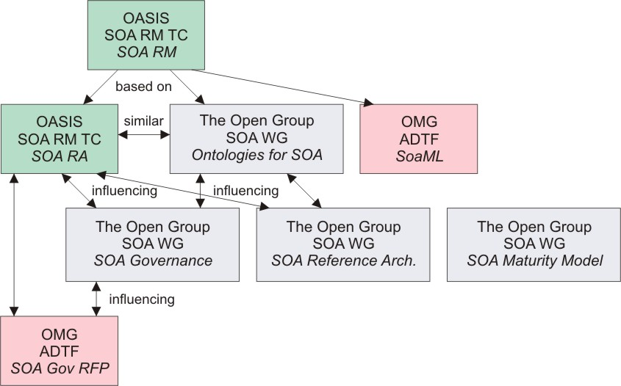
Figure 2: Relationship between Relevant SOA Open Technical Products
How the Technical Products Fit Together
These technical products represent different perspectives and levels of abstraction within the overall SOA landscape. Below we discuss how they all serve a common purpose of jointly facilitating understanding.
Figure 3 depicts some of the basic tools used by an architect illustrating different artifacts at different levels of abstraction.
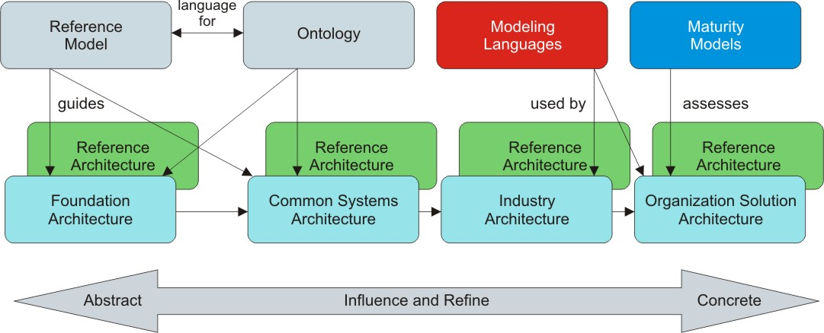
Figure 3: Influence of Technical Products on Architecture Work
A reference model, much like an ontology, is a high-level conceptualization of a domain but without formal semantics and rules to support automated reasoning that would be characteristic of an ontology. A formal ontology can be used to formally describe a particular reference model. Both capture the core concepts within a domain and explain how those core concepts relate to each other devoid of implementation details. Reference models and ontologies are useful to capture and preserve knowledge that helps users to understand the “essence” of the domain. Reference models and ontologies guide architectures and reference architectures. A modeling language may be an instantiation of a reference architecture that enables the automation and interchange of instances of the model.
Architectures reflect a wide range of levels of concreteness and domain specifics. We can exploit some concepts of enterprise architecture to help establish a relationship between the SOA specifications and provide some guidance on use of these specifications. The elements of an enterprise architecture can be explained along two continuums: levels of abstraction, and completeness of coverage [2].
The abstraction continuum is explained well by The Open Group TOGAF Architecture Continuum [11] illustrated in the bottom half of Figure 3. According to TOGAF Version 9, architectures exist along a continuum from abstract foundation architectures to concrete organization-specific architectures.
- Foundation Architectures are composed of building blocks and corresponding standards that support all the common systems architectures.
- Common Systems Architectures guide the selection and integration of specific services from the foundation architecture to create an architecture useful for building common (i.e., highly re-usable) solutions across a wide number of relevant domains; e.g., security and management architectures.
- Industry Architectures guide the integration of common systems components with industry-specific components, and guide the creation of industry solutions for targeted customer problems within a particular industry.
- Organization-Specific Architectures describe and guide the final deployment of solution components for a particular enterprise or extended network of connected enterprises. There may be a variety of organization-specific architectures that are needed to effectively cover the organization's requirements by defining the architectures in increasing levels of detail.
Reference architectures exist along the same continuum as these architectures – as depicted in Figure 3 – from conceptual to solution reference architectures:
- Conceptual reference architectures capture fundamental patterns and concepts that should be applicable for all domains and more specific reference architectures. Conceptual reference architectures support foundation architectures.
- Generic reference architectures are more defined and restrictive than conceptual reference architectures, but still applicable across domains, industries, and organizations. Generic reference architectures support common systems architectures.
- Industry reference architectures are more detailed and restrictive than generic reference architectures and are usually applicable to a single industry domain, but across organizations. Industry reference architectures support industry architectures.
- Enterprise and solution reference architectures are the most concrete and targeted to a specific solution in an organization. Enterprise and solution reference architectures support organization-specific architectures [2].
Reference architectures may identify architectural decisions to be made when moving from a conceptual reference architecture towards a solution architecture. Conceptual reference architectures have more degrees of freedom and fewer architectural decisions that have been made than more specific enterprise reference architectures. More specific reference architectures often include the results of architectural decisions made for a specific project and to assist in developing associated concrete solution architectures, as shown in Figure 4. For more specific architectures, care must be exercised to ensure the incorporated choices match the situation to which it is being applied.
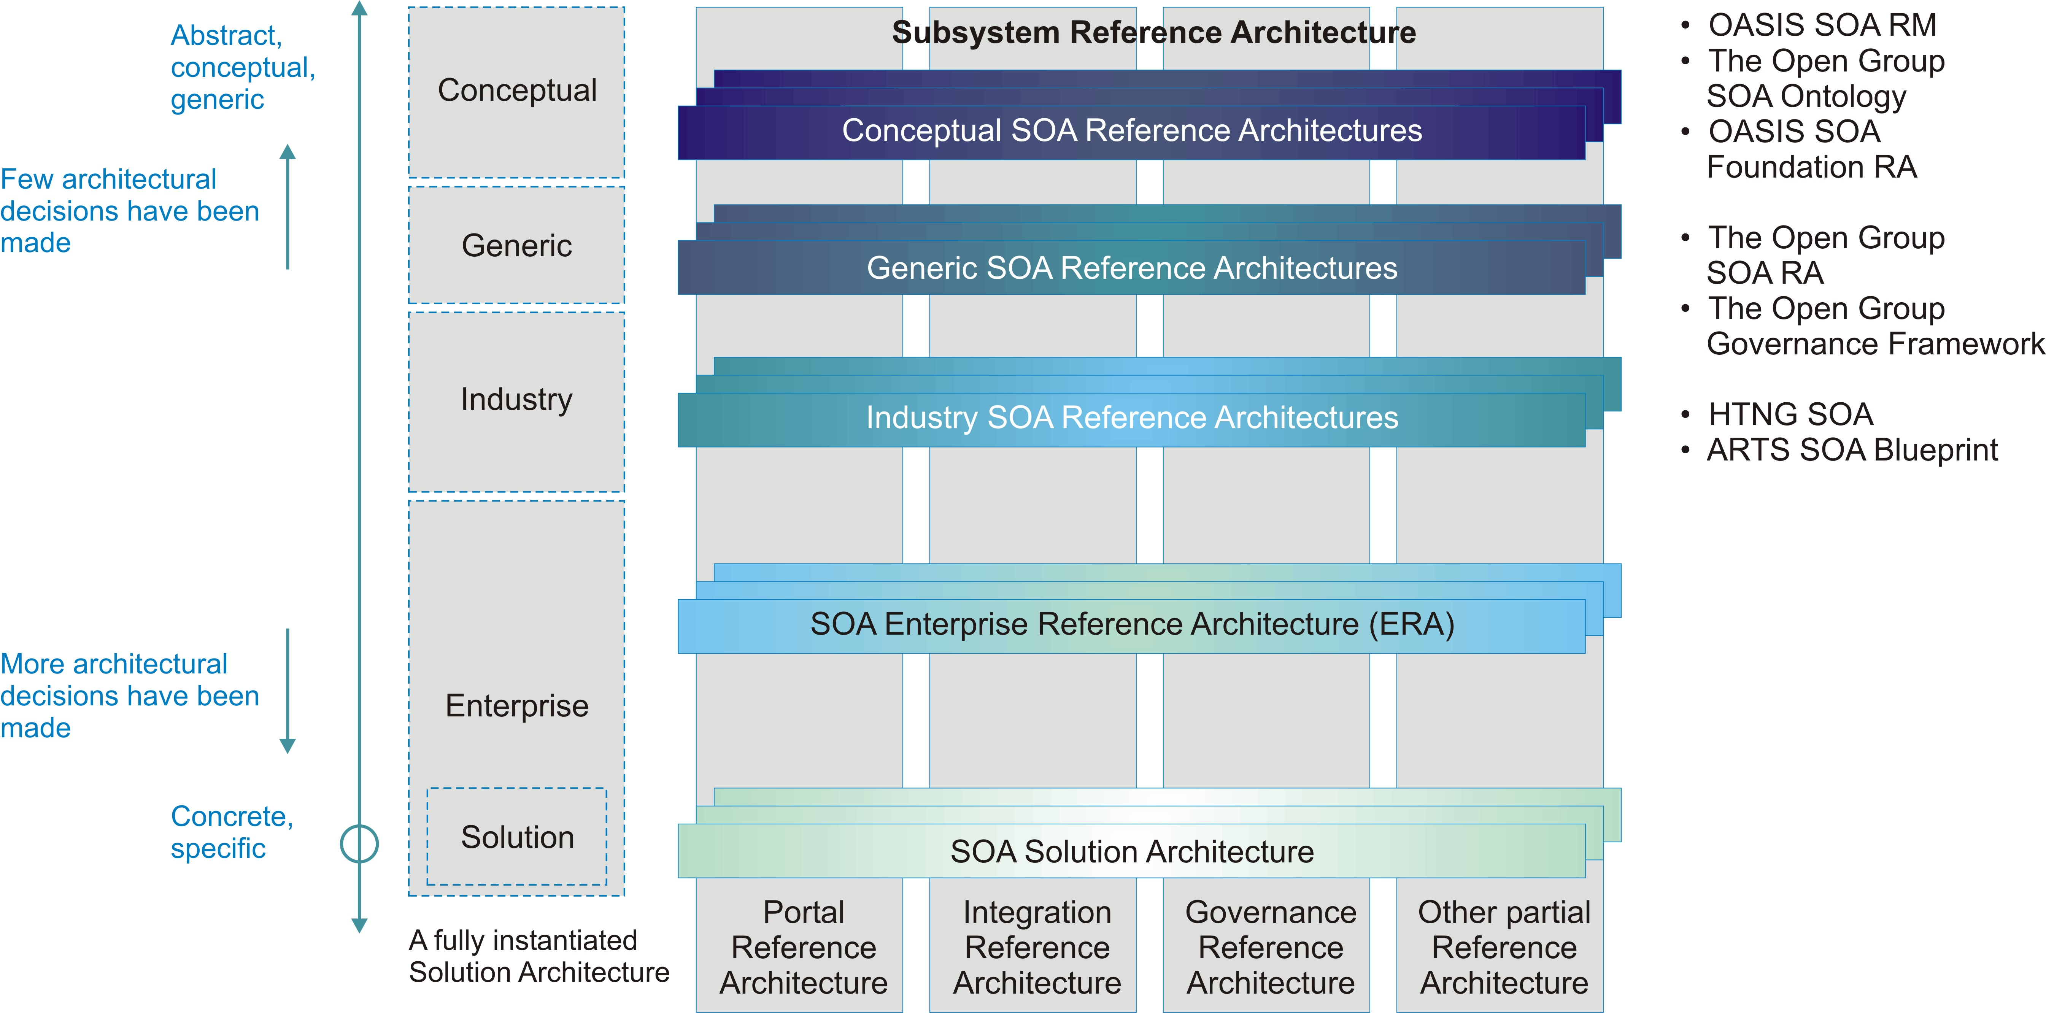
Figure 4: SOA Reference Architecture Continuum [2]
The other continuum in which reference architectures exist is the breadth or completeness of coverage which ranges from architectural patterns, partial reference architectures, IT reference architectures, to end-to-end reference architectures, as shown in Figure 4. Partial reference architectures are narrowly scoped and cover only one (or a few) aspect or domain, like security, governance, or management. End-to-end, or comprehensive reference architectures cover both business and IT aspects. A set of partial reference architectures can contribute to providing the end-to-end reference architectures.
The reference architecture grid shown in Figure 5 can be used to position the specifications discussed in this document. They can be positioned relative to each other in terms of level of abstraction and completeness of coverage.
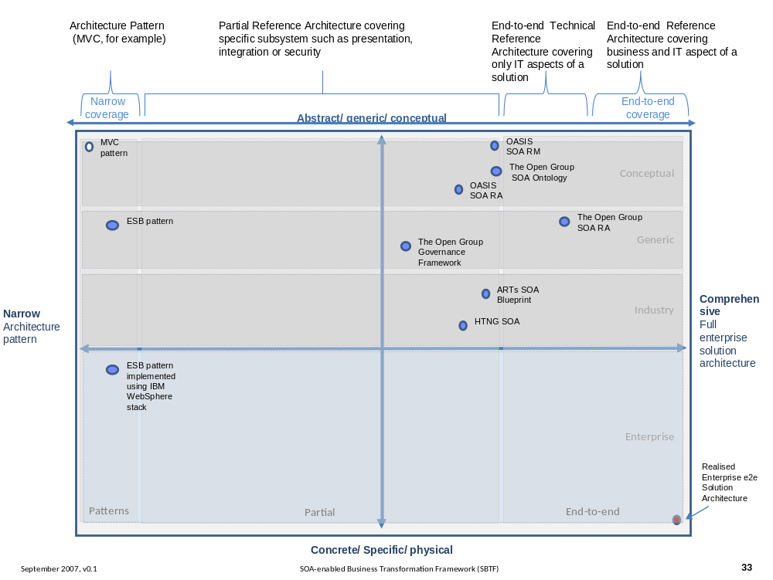
Figure 5: SOA Reference Architecture Positioning [2]
While the OASIS Reference Model for SOA [5] and The Open Group SOA Ontology [14] are not reference architectures, we position them to show they are more conceptual than the reference architectures. The Open Group SOA Ontology is positioned as being slightly less abstract than the OASIS Reference Model for SOA, since it provides a normative expression of the SOA Reference Model with extensions. The OASIS Reference Architecture for SOA Foundation [6] is less abstract than the OASIS Reference Model for SOA and The Open Group SOA Ontology, since it provides significantly more detail on architectural components and their relationships, but provides a subset of the architectural views available. The Open Group SOA Reference Architecture [17] is less abstract than the OASIS Reference Architecture for SOA Foundation and provides more coverage of an enterprise architecture.
The Open Group SOA Governance Framework [15] can be categorized as a generic, domain-specific, partial reference architecture. The OASIS Reference Architecture for SOA Foundation also includes SOA governance.
Examples of the industry reference architectures are the ARTS XML SOA Blueprint for Retail [47] and the Service Oriented Realization of the HTNG Reference Architecture [48], but these will not be discussed further in this document.
Examples of architectural patterns are Enterprise Service Bus (ESB) and Model-View-Controller (MVC), but they are not discussed further here.
SOA Core Concepts
While the definitions and expressions may differ slightly, the open standards organizations referenced in this document agree on the following fundamental concepts of SOA:
- SOA – SOAs support thinking and organizing in terms of services with distributed capabilities which may be under the control of different ownership domains, and is an architectural style as well as a paradigm for business and IT architecture.
- Service – Services correspond to repeatable activities that can be characterized as capabilities or the access to capabilities, that capabilities satisfy specific needs, that services are self-contained, that services are described, and that access and interaction with services are constrained by policies and contracts. We agree that the service implementation is opaque to service consumers who interact with the service.
- Effect (or real-world effect) – Interacting with services has a purpose and therefore has some outcome which potentially provides exchange of value between consumers and providers.
- Visibility – Participants, more specifically providers with capabilities and consumers with needs, are able to interact with each other. We agree that availability of service descriptions and policies support these interactions.
- Service Description – Services are described with sufficient information in order to determine whether they meet the needs of prospective consumers as well as how to access and interact with them, including but not limited to interfaces, information models, policies, and contracts.
- Policies and Contracts – Service policies represent some constraint, condition, or expectation on the use of services represented by a consuming participant or commitment of a providing participant, and that service contracts represent an agreement by two or more parties.
- Execution Context – In order for services to be invoked, there must be an established path between consumers and providers. In other words, to realize described effects, consumers and providers must acknowledge and comply with a consistent set of agreements in order to have a successful service interaction.
- Interaction – There is some activity involved in making use of capabilities offered by services in order to achieve desired effects.
Open Standards Work on SOA Governance
SOA Governance frameworks are defined both in The Open Group SOA Governance Framework [15] and as a chapter in the OASIS Reference Architecture for SOA Foundation [6]. The OMG SOA Governance RFP development group [36] is also exploring the standardization of SOA governance. While the understanding of SOA governance provided by these works is similar, they are written from different perspectives. Each specification supports the same range of opportunity, but has provided different depths of detail for the perspectives on which they focus. The following table outlines some of the aspects of the governance specifications that had different emphasis.
Organization | OASIS Reference Architecture  for SOA | The Open Group SOA Governance Framework
Abstractness | More abstract, covering wide range of concepts but not detailing any particular one. | More concrete, providing more detail for specific conditions.
Goals | Focus on conveying understanding of SOA governance. | Focus on guidance for architects adding governance to SOA processes.
Boundaries | Focus on governance among peers across ownership boundaries. | Focus on governance within an organization.
Controlling Body | Focus on coordination among peers with controlling body being facilitator running framework for coordination. | Focus on coordination among peers who are subordinate to controlling body.
Target of Governance | Focus on SOA infrastructure, service inventory, and participant interaction. | Focus on service and SOA solution portfolio and lifecycle process.

SOA Governance Concepts
These works define similar concepts for SOA governance, SOA governance frameworks, and SOA governance reference models:
- SOA Governance is an enhancement of enterprise governance that recognizes the distinct concerns of SOA, particularly sharing of services/capabilities across organizational boundaries, that ensures continued alignment of business goals and SOA solutions. It covers the definitions of standards, guidelines, policies, and metrics for current SOA processes which are monitored with compliance processes.
- SOA Governance Framework includes organizational, technology, and process governance customized for an organization.
- SOA Governance Reference Model (The Open Group) and Generic Model for Governance (OASIS) establish the core concepts of SOA governance and the relationships between them.
Many of these core concepts are core to governance in general and not specific to SOA. As a result of different perspectives, there is different emphasis, focus, and detail in the reference models. The core concepts are very similar in both reference models and are summarized and compared in this section:
- EA Governance – We agree that IT, EA, and SOA governance influence each other. We agree that if an EA is available, then it should provide a foundation for governance; if no EA work has been done, then much of that work will become part of the SOA and SOA governance work.
- People – We agree that SOA governance involves roles including stakeholders, where the stakeholders may include organizations, boards, and other groupings that facilitate defining and assigning the responsibilities of governance.
- Technology – We agree that it includes technology for enabling SOA governance. We agree that SOA governance should provide guidance to and ensure that SOA IT infrastructure used as part of SOA is used according to policies, rules, and regulations. We agree that SOA and SOA governance influence IT infrastructure and IT governance.
- Guiding Principles – We agree that The Open Group guiding principles are roughly the same as the OASIS policies, and provide a means for aligning business and SOA objectives and influencing how SOA governance is defined and deployed.
- Roles – We agree that roles and responsibilities should be considered as part of an organization’s SOA and that participants in SOA include stakeholders, leadership, and governance bodies.
- Governing Processes – We agree that it must be possible to assess compliance and respond appropriately, where the response may be recognition/benefits for exemplary compliance, dispensation where flexibility enables accounting for local conditions, or penalties where compliance targets are missed. The actions of governance must also be communicated to the stakeholders. The governing processes are enabled by the implementation of:
  - Checkpoints – We agree that checkpoints – identified stop points to check for governance compliance – can be used to enable governance of SOA solutions.
  - Metrics – We agree that metrics should be identified and collected to support compliance and monitoring. We agree that metrics should be available to relevant stakeholders.
  - Artifacts – We agree that governance is supported by artifacts which include service descriptions, policies, and documentation on the governance regimen and governing processes.
- Governed Processes – We agree that the target of SOA governance includes services, solutions, technology, and processes. We agree that SOA solutions and lifecycles should be governed; however, OASIS does not get into the details of doing this.
- Vitality – We agree that SOA governance is an ongoing process that should have a feedback loop to keep it current and aligned with long-term goals for SOA in the organization. We agree that plan, define, implement, and monitor stages occur iteratively as part of the ongoing process of governance and to ensure vitality.
Guidance and Usage of Technical Products
Which architecture-related technical products are relevant to you depends on what you are trying to achieve on a project and in your organization. It also depends on your existing experience with SOA and your organization’s experience with SOA (i.e., level of maturity – the SOA maturity model, OSIMM, can provide some insight on this). In this section we provide advice based on what a reader is looking to learn or understand. We recognize that there are other valid approaches to understanding and using these specifications, and that the approach that is most effective depends on the stakeholders, their needs, and particular viewpoints.

Core Concepts
- Understanding SOA core concepts: The OASIS Reference Model for SOA [5] provides a common vocabulary for understanding the “essence” of SOA. It is, by design, a highly abstract model targeting a large, cross-cutting audience that includes non-technical readers as much as it does technical readers. The Open Group SOA Ontology [14] builds on the OASIS Reference Model for SOA and provides additional SOA concepts and relationships taken from the viewpoints of different stakeholders as well as an enterprise-wide perspective. It also provides as a common language for formally describing SOA concepts that can be leveraged by abstract as well as solution-oriented reference architectures.
Other specifications [6] [9] [16] [17] also articulate core SOA concepts to provide context for their specifications; these concepts are consistent with the SOA concepts outlined in this document.

Architectures
- Understanding the different elements of an SOA: The Open Group SOA Reference Architecture [17] defines the key architectural elements in SOA and the key relationships between these elements relevant to enterprises. The OASIS Reference Architecture for SOA Foundation [6] does this as well for the SOA ecosystem and ownership viewpoints.
- Understanding considerations for cross-ownership boundaries of SOA ecosystems: While both SOA reference architectures provide guidance that is important for SOA implementations that span ownership boundaries, the OASIS Reference Architecture for SOA Foundation [6] is especially focused on this scenario and provides architectural considerations for interacting with services owned by another company.
- Understanding the completeness of SOA architectures and implementations: The OASIS Reference Architecture for SOA Foundation [6] provides models that function as a checklist that can be used to evaluate architectures and implementations of SOA.
- Understanding the deployment of SOA in an enterprise: The Open Group SOA Reference Architecture [17] provides a stack organization of SOA architectural building blocks for an enterprise and guidance on the use and deployment of these building blocks.
- Understanding the basis for an industry or organizational reference architecture: The Open Group SOA Reference Architecture [17] provides guidance on refining this SOA reference architecture into an industry or solution SOA reference architecture.
- Understanding the implications of architectural decisions: The Open Group SOA Reference Architecture [17] provides guidance to SOA designers and implementers by providing a concrete basis for making architectural and design decisions. It provides a model and framework for evaluating architectural concerns for designing an SOA.
- Understanding how to position vendor products in an SOA context: The Open Group SOA Reference Architecture [17] provides a layered stack with architectural building blocks and capabilities that map naturally to vendor products available to support SOA.
- Understanding SOA governance: Both The Open Group SOA Governance Framework [15] and the OASIS Reference Architecture for SOA Foundation [6] contain very similar basic concepts of SOA governance. There are some differences in the targets of SOA governance. The Open Group SOA Governance Framework focuses on governing SOA processes which call into scope the service portfolio and IT infrastructure that the SOA is deployed onto. The OASIS Reference Architecture for SOA Foundation focuses on governing services and IT infrastructure directly. The Open Group SOA Governance Framework also provides guidance on the deployment of SOA governance in an enterprise in an iterative, progressive cycle.

Maturity
- Understanding the level of SOA maturity in an organization: OSIMM [16] provides an SOA integration maturity model that describes the scope of SOA, so that companies can understand what SOA features they are using and the ones they want to use.

Modeling Languages
- Understanding representing SOA artifacts in UML: The OMG SoaML [9] provides a profile that extends UML for modeling SOA artifacts and services for your SOA as part of the transformation from a reference architecture to your SOA solution architecture. These models can be considered the result of following governed processes for creating and evaluating the SOA.
Summary
An abundance of specifications and standards have emerged from the open standards organizations of OASIS, OMG, and The Open Group on the subject of Service Oriented Architecture (SOA). This document was written to help the SOA community at large to navigate the myriad of overlapping technical products produced by these organizations with specific emphasis on the “A” in SOA; i.e., Architecture.
Fortunately, there is a great deal of agreement on the foundational core concepts across the many independent open specifications and standards for SOA. This could best be explained by broad and common experience of users of SOA and its maturity in the marketplace. It also provides assurance that investing in SOA-based business and IT transformation initiatives that incorporate and use these open specifications and standards helps to mitigate risks that might compromise a successful SOA solution.
The specifications and standards described in this document can be used together in many complementary ways. An excellent example is incorporating the use modeling techniques into an SOA project by using SoaML in concert with an SOA reference architecture. In addition, the SOA reference models, ontology, and reference architectures described in this document can be used as input to requests for proposals (RFPs) that extend SoaML with additional modeling capabilities.
Users of the technical products produced by the open standards organizations should make every effort possible to understand the strengths of each body of work and select the technical products most appropriate for their needs, consistent with where they are today, and where they plan to head on their SOA journeys. The Open Group Service Integration Maturity Model (OSIMM) can be used to help assess the SOA needs and goals of an organization or project and help gain insight into which of these specifications and standards is most relevant to the problem at hand.
We anticipate continuing the collaborative efforts of our respective SOA architecture-related specifications and standards to ensure that they continue to evolve in as consistent and complete a manner as possible.
References

Papers and Briefings
[1] Design an SOA Solution Using a Reference Architecture, A. Arsanjani, L-J. Zhang, M. Ellis, A. Allam, K. Channabasavaiah; paper available on IBM developerWorks, March 2007:
www.ibm.com/developerworks/library/ar-archtemp
[2] Enterprise Reference Architecture, A. Fattah; paper presented at 22nd Enterprise Architecture Practitioners Conference, London, UK, April 2009:
www.opengroup.org/london2009-apc/fattah.htm
Also Via Nova Architectura Journal, May 2009:
www.via-nova-architectura.org/magazine/magazine/enterprise-reference-architecture.html
[3] A Translation Approach to Portable Ontology Specification. T.R. Gruber, Knowledge Acquisition, 5:199-220, 1993: tomgruber.org/writing/ontology-definition-2007.htm
[4] OMG SOA SIG Activity, E. Harrington, presentation given at the SOA Summit, 21st Enterprise Architecture Practitioners Conference, San Diego, CA, US, February 2009:
www.opengroup.org/sandiego2009-apc/harrington.html

Formal Specifications, Standards, and RFPs
[5] OASIS Reference Model for SOA, Version 1.0, OASIS Standard, October 2006:
docs.oasis-open.org/soa-rm/v1.0/soa-rm.pdf
[6] OASIS Reference Architecture for SOA Foundation, Version 1.0, OASIS Public Review Draft 1, April 2008: docs.oasis-open.org/soa-rm/soa-ra/v1.0/soa-ra-pr-01.pdf
[7] OMG Agent Metamodel and Profile (AMP) RFP: www.omg.org/cgi-bin/doc?ad/08-09-05
[8] OMG Event Metamodel and Profile (EMP) RFP: www.omg.org/cgi-bin/doc?ad/08-09-15
[9] OMG SOA Modeling Language (OMG SoaML) Specification for the UML Profile and Metamodel for Services (UPMS), Revised Submission, OMG Doc. No.: ad/2008-11-01, Object Management Group (OMG), November 2008: www.omg.org/cgi-bin/doc?ad/08-11-01
[10] OMG Unified Modeling Language (OMG UML), Superstructure, Version 2.2, OMG Doc. No.: formal/2009-02-02, Object Management Group (OMG), February 2009:
www.omg.org/spec/UML/2.2/Superstructure
[11] The Open Group Architecture Framework (TOGAF), Version 9 Enterprise Edition, February 2009; refer to www.opengroup.org/togaf
[12] The Open Group Definition of Service Oriented Architecture (SOA), June 2006; refer to www.opengroup.org/projects/soa/doc.tpl?CALLER=index.tpl&gdid=10632
[13] The Open Group SOA Source Book, G093, April 2009: refer to www.opengroup.org/bookstore/catalog/g093.htm
[14] The Open Group SOA Ontology, Draft Technical Standard (to be published in 2009); refer to www.opengroup.org/projects/soa-ontology
[15] The Open Group SOA Governance Framework, Draft Technical Standard (to be published in 2009); refer to www.opengroup.org/projects/soa-governance
[16] The Open Group Service Integration Maturity Model (OSIMM), Draft Technical Standard (to be published in 2009); refer to www.opengroup.org/projects/osimm
[17] The Open Group SOA Reference Architecture (The Open Group SOA RA), Draft Technical Standard (to be published in 2009); refer to www.opengroup.org/projects/soa-ref-arch
[18] Service Oriented Architecture (SOA), White Paper by The Open Group SOA Work Group, W074, July 2007; refer to www.opengroup.org/bookstore/catalog/w074.htm
[19] Web Ontology Language (OWL), World Wide Web Consortium (W3C), April 2009:
www.w3.org/2007/OWL/wiki/OWL_Working_Group
[20] Model Driven Architecture (MDA) Guide, Version 1.0.1, Object Management Group (OMG), June 2003: www.omg.org/docs/omg/03-06-01.pdf

Technical Committees, Work/Working Groups, Interest Groups
[21] IEEE P1600.1 Standard Upper Ontology Working Group (SUO WG), IEEE, December 2003:
suo.ieee.org
[22] OASIS Open Composite Services Architecture (Open CSA) Member Section:
www.oasis-opencsa.org
[23] OASIS SOA-Related Technical Committees:
www.oasis-open.org/committees/tc_cat.php?cat=soa
[24] OASIS Semantic Execution Environment TC:
www.oasis-open.org/committees/tc_home.php?wg_abbrev=semantic-ex
[25] OASIS Service Component Architecture/Assembly (SCA-Assembly) TC:
www.oasis-open.org/committees/tc_home.php?wg_abbrev=sca-assembly
[26] OASIS Service Component Architecture/Bindings (SCA-Bindings) TC:
www.oasis-open.org/committees/tc_home.php?wg_abbrev=sca-bindings
[27] OASIS Service Component Architecture/BPEL (SCA-BPEL) TC:
www.oasis-open.org/committees/tc_home.php?wg_abbrev=sca-bpel
[28] OASIS Service Component Architecture/C and C++ (SCA-C-C++) TC:
www.oasis-open.org/committees/tc_home.php?wg_abbrev=sca-c-cpp
[29] OASIS Service Component Architecture/J (SCA-J) TC:
www.oasis-open.org/committees/tc_home.php?wg_abbrev=sca-j
[30] OASIS Service Component Architecture/Policy (SCA-Policy) TC:
www.oasis-open.org/committees/tc_home.php?wg_abbrev=sca-policy
[31] OASIS Service Data Objects (SDO) TC:
www.oasis-open.org/committees/tc_home.php?wg_abbrev=sdo
[32] OASIS SOA End-to-End Resource Planning (SOA-EERP) TC:
www.oasis-open.org/committees/tc_home.php?wg_abbrev=soa-eerp
[33] OASIS SOA for Telecom (SOA-Tel) TC:
www.oasis-open.org/committees/tc_home.php?wg_abbrev=soa-tel
[34] OASIS SOA Reference Model TC:
www.oasis-open.org/committees/tc_home.php?wg_abbrev=soa-rm
[35] OMG SOA Special Interest Group (SOA SIG): soa.omg.org
[36] OMG SOA Governance Metamodel and Profile (SGMP) Standard Wiki:
www.omgwiki.org/soagov/doku.php
[37] Service Oriented Architecture (SOA), White Paper by The Open Group SOA Work Group, W074, July 2007; refer to www.opengroup.org/bookstore/catalog/w074.htm
[38] The Open Group SOA Work Group (SOA WG): www.opengroup.org/projects/soa
[39] The Open Group SOA Governance Project: www.opengroup.org/projects/soa-governance
[40] The Open Group SOA Reference Architecture Project: www.opengroup.org/projects/soa-ref-arch
[41] The Open Group Service Oriented Infrastructure Project: www.opengroup.org/projects/soa-soi
[42] The Open Group Service Oriented Infrastructure Reference Framework, Draft Technical Standard (to be published in 2009); refer to www.opengroup.org/projects/soa-soi
[43] The Open Group Service Integration Maturity Model (OSIMM) Project:
www.opengroup.org/projects/osimm
[44] The Open Group SOA TOGAF Practical Guide Project: www.opengroup.org/projects/soa-togaf
[45] The Open Group SOA and Security Project: www.opengroup.org/projects/soa-sec
[46] The Open Group SOA Legacy Evolution Project: www.opengroup.org/projects/soa-legacy
[47] ARTS XML SOA Blueprint for Retail, Version 1.1, Candidate Recommendation, Association for Retail Technology Standards (ARTS), National Retail Federation, July 2008: nrf-arts.org
[48] Service-Oriented Realization of the HTNG Reference Architecture, Version 1.0, Hoteliers Technology Next Generation (HTNG), March 2009: www.htng.org and www.opengroup.org/htng/specs
[49] World Wide Web Consortium (W3C): www.w3c.org
[50] Business Modeling and Integration DTF (BMI), Object Management Group (OMG): bmi.omg.org
[51] Business Process Modeling Notation (BPMN), Version 2, Object Management Group (OMG): www.omg.org/spec/BPMN
[52] Business Motivation Model (BMM), Object Management Group (OMG): www.omg.org/spec/BMM
[53] C4I (Consultation, Command, Control, Communications, and Intelligence) DTF, Object Management Group (OMG): c4i.omg.org
[54] Unified Profile for DoDAF and MODAF (UPDM), Object Management Group (OMG): www.updm.com
[55] Analysis & Design Platform Task Force (ADTF), Object Management Group (OMG): adtf.omg.org
[56] Information Management Metamodel (IMM), Object Management Group (OMG): www.omgwiki.org/imm/doku.php
[57] Ontology Definition Metamodel (ODM), Object Management Group (OMG): www.omg.org/ontology
[58] Value Delivery Metamodel (VDM) RFP, Object Management Group (OMG):
www.omg.org/cgi-bin/doc?bmi/09-03-09
About the Authors

About the OASIS SOA-RM TC
The OASIS SOA Reference Model Technical Committee (OASIS SOA-RM TC) advances a core reference model to guide and foster the creation of specific, service-oriented architectures. The group is part of OASIS (Organization for the Advancement of Structured Information Standards), a not-for-profit consortium that drives the development, convergence, and adoption of open standards for the global information society. More information is available at www.oasis-open.org/committees/soa-rm.

About OMG
OMG is an international, open membership, not-for-profit computer industry consortium. OMG Task Forces develop enterprise integration standards for a wide range of technologies, and an even wider range of industries. OMG’s modeling standards enable powerful visual design, execution, and maintenance of software and other processes. OMG’s middleware standards and profiles are based on the Common Object Request Broker Architecture (CORBA) and support a wide variety of industries. All of our specifications may be downloaded without charge from our website (www.omg.org).

About The Open Group
The Open Group is a vendor-neutral and technology-neutral consortium, whose vision of Boundaryless Information Flow™ will enable access to integrated information within and between enterprises based on open standards and global interoperability. The Open Group works with customers, suppliers, consortia, and other standards bodies. Its role is to capture, understand, and address current and emerging requirements, establish policies, and share best practices; to facilitate interoperability, develop consensus, and evolve and integrate specifications and Open Source technologies; to offer a comprehensive set of services to enhance the operational efficiency of consortia; and to operate the industry's premier certification service, including UNIX® system certification. Further information on The Open Group can be found at www.opengroup.org.

OSIMM is an Open Group Board Project rather than an SOA Work Group project.

